This document describes how to post announcements into the ward facebook page, and into the ward website.

Facebook:

1. Log into facebook.
2. Click on ‘Groups’
3. Select “Santaquin 10th Ward neighborhood Group”
   1. This group is accessible under this link: <https://www.facebook.com/groups/535347663203706>
4. Copy all of the data from the announcements, and create a new post.
   1. Click in the “Write something” field, as you would a normal post.
   2. Paste in the data from the source.
   3. Click save.
   4. Click on the three dots menu button of the post and select ‘Pin to Featured’ so the announcements are obvious and stay at the top of the group.

The announcement will appear like this - See the first ‘Featured’ item at the top of the page:

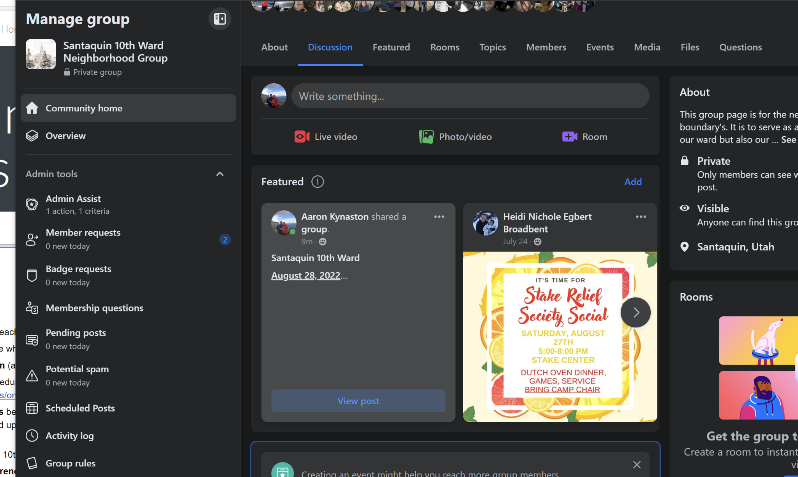

Ward Website

1. Log in to the Santaquin 10th Ward google account.
2. Go to this link:
   1. <https://sites.google.com/d/1OL6CyAhAYaZ-DipxHI5e-70YxRA59Yl5/p/1V8G80mziimqGE-nkMhySsjx9CsemKhQI/edit>
   2. This is the edit screen for the ward website.
3. In the upper right-hand corner, click ‘Pages’ -> ‘Announcements’
4. Click in the body of the text on the page at the very top, then press enter a few times as follows:

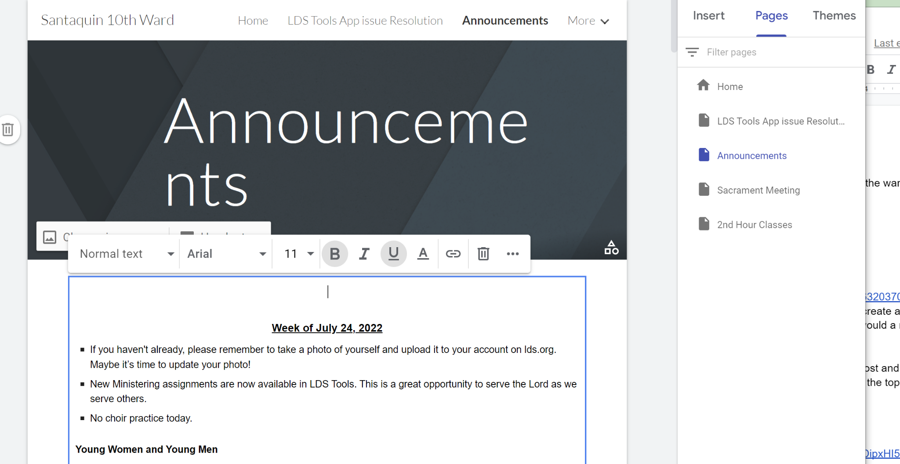

1. In another tab, copy all of the announcement data.
2. Click back to the announcement edit page, and paste the latest week at the top.
3. Delete older weeks as desired.
4. Go to the live website after about 30 seconds to 2 minutes, and verify the updates look as expected:
   1. <https://www.santaquin10thward.com/announcements>